**WEEK 3 VIDEO 2**

**ServiceNow Administration & Developer Overview**

**What is ServiceNow?**

* ServiceNow is a cloud-based platform, which was mainly developed for workflow and process automation as per the ITIL principles.
* ServiceNow contains a dedicated workflow available which we have to learn and which we need to apply on the logics which we are going to develop so this provide.
* It provides PaaS which is one part of cloud where you will have to create your own application on that particular platform and that platform will automatically host your application on the cloud without writing a single line of code.

**Who uses ServiceNow?**

The following stakeholders use ServiceNow to achieve their business goals:

1. Employees: Use it to request their related IT business services.
2. IT Support Team: Use it to manage service requests or incidents.
3. Administrators: Helps user access, roles, and privilege management.
4. Implementers: Use it to deploy process applications and platform features fulfilling an organization's business needs.
5. Developers: Create new functionality with scripts to extend standard configurations.

**What is a catalog?**

In ServiceNow, a catalog refers to the Service Catalog, a user-friendly interface allowing users to request various IT and corporate services. It serves as an enterprise storefront where items such as services and products can be browsed and requested. Catalog Items represent the predefined offerings available for users to request from this Service Catalog.

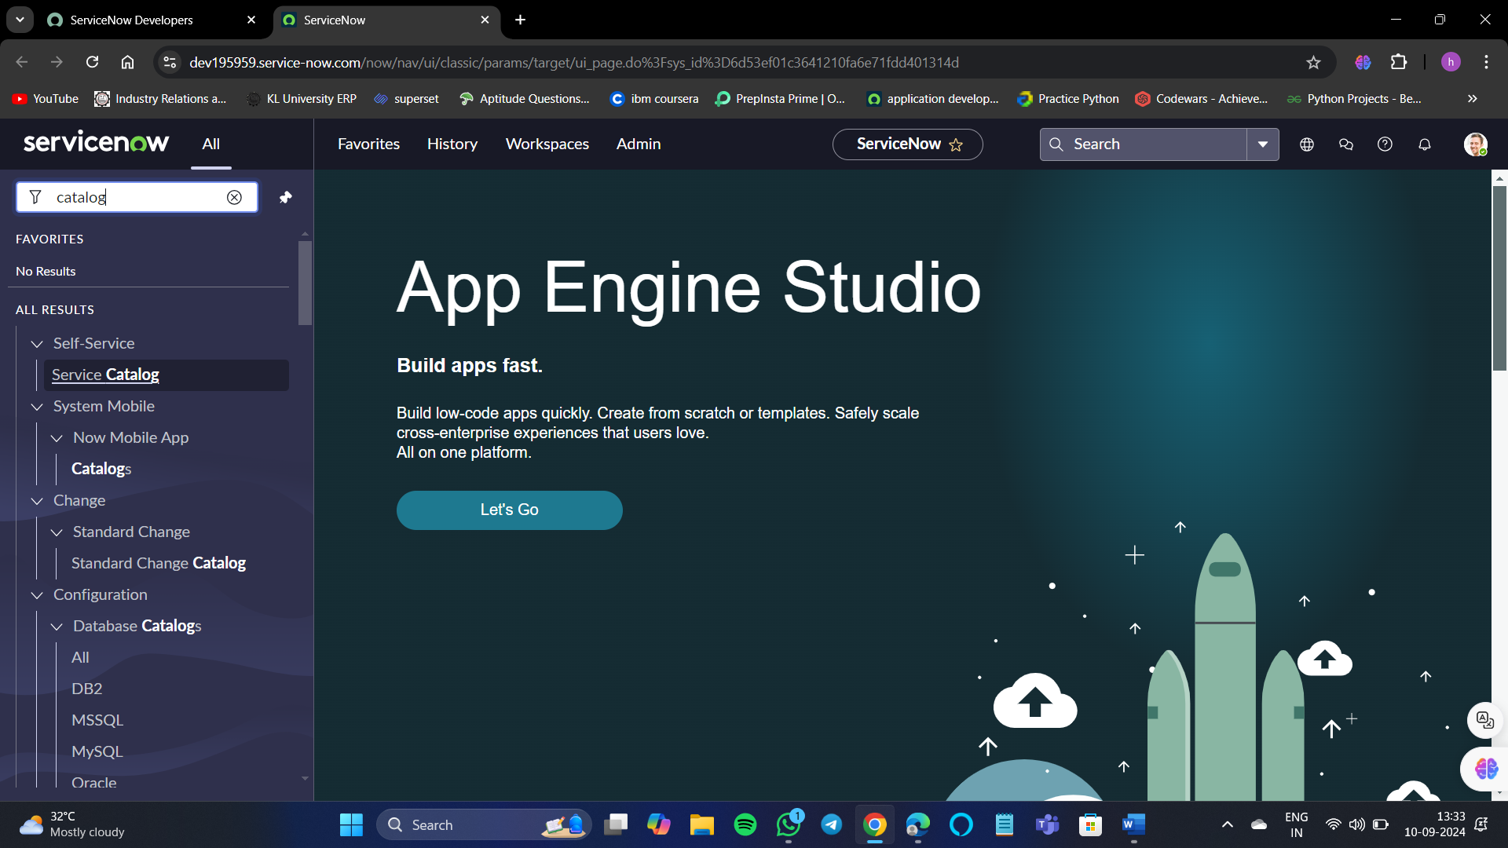

This is what it looks like. Here we can order items of our choice.

For example, I want to order an mini Ipad.

We can choose the color of our choice and even the description is present for the product which you are going to buy.

We can keep the items in the cart an can check out together with all the items at once.

**Dashboard Creation:**

